*WEEK 5*

**E-COMMERCE WEBSITE**

***OUTPUT***

***Home Page***

*The home page serves as the main interface where users can browse and select products. The navigation bar includes links to the Home and Cart pages, allowing smooth transitions between them.*

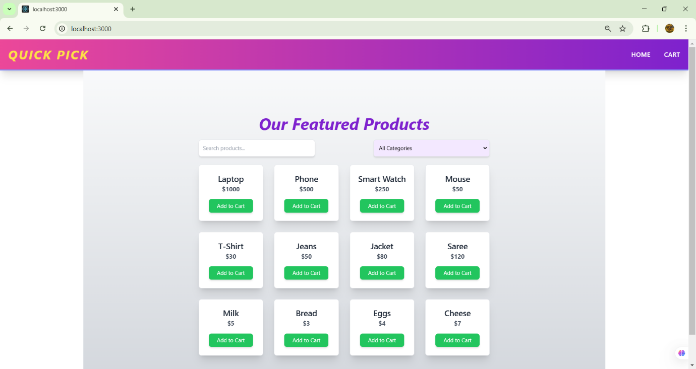

***Product Selection***

Users can select products through a dropdown menu or manually enter the product name to find their desired item. This enhances the user experience by providing multiple ways to search for products efficiently.

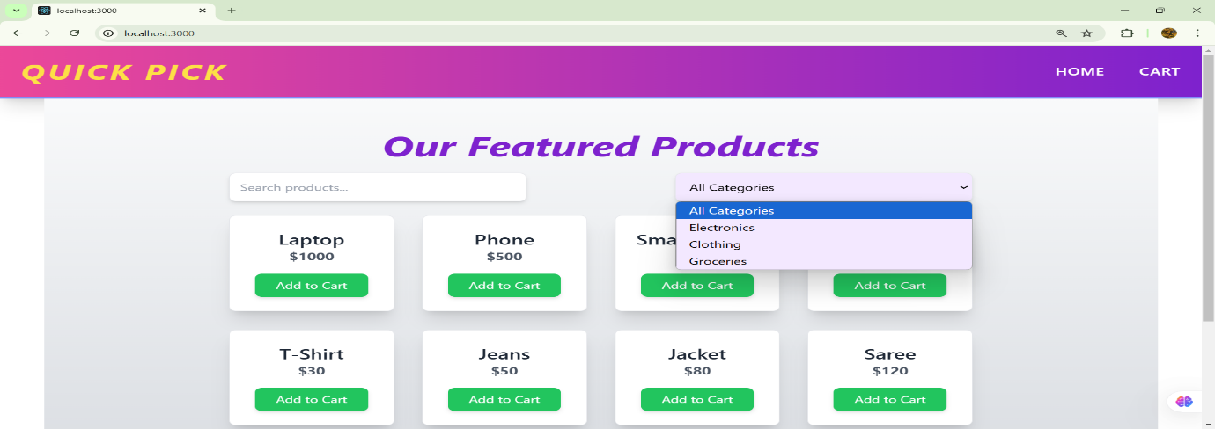

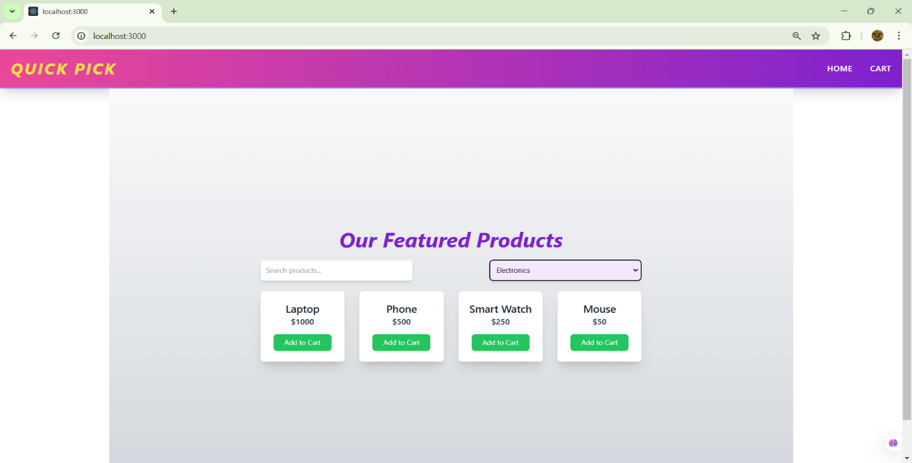

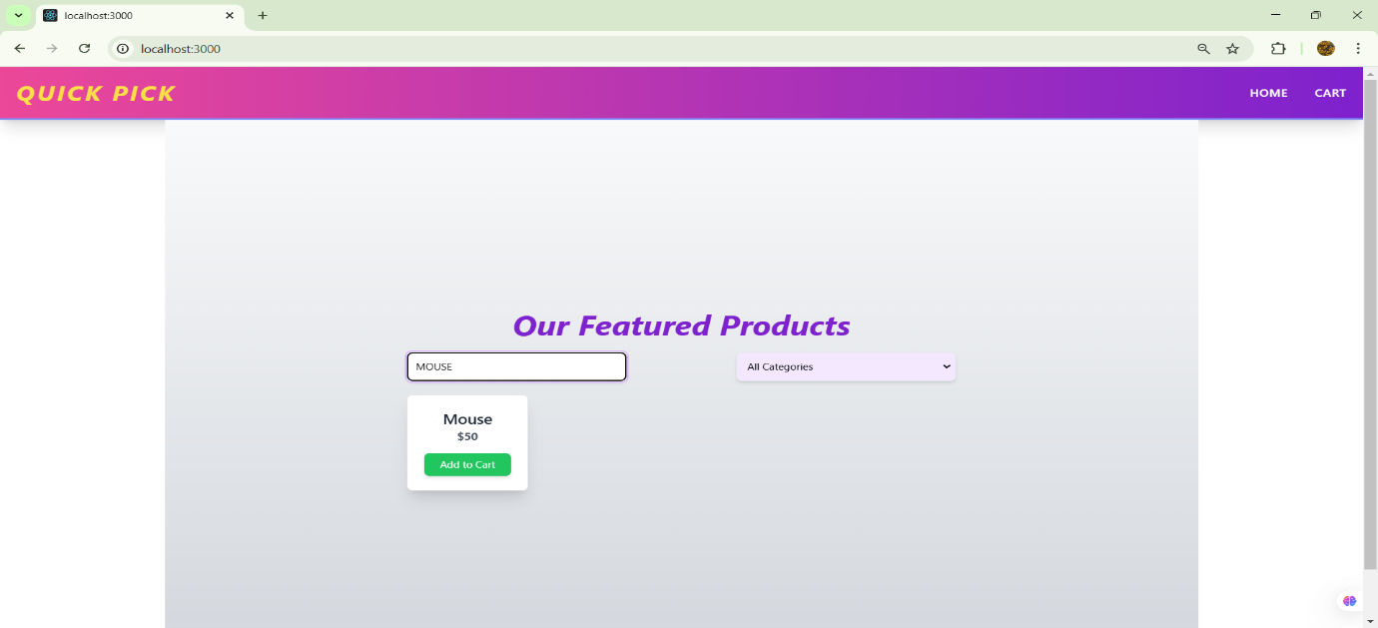

***Adding Products to the Cart***

*Each product listing includes an "Add to Cart" button. Clicking this button adds the selected product to the cart, making it easy for users to keep track of their selections.*

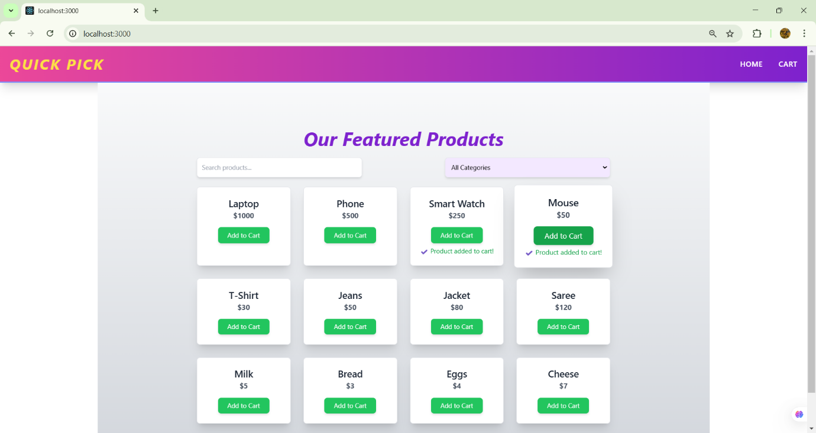

***Cart Page - Viewing Added Products***

*The cart page displays all the products added by the user along with their total price. This page provides an overview of the selected items before proceeding with further actions.*

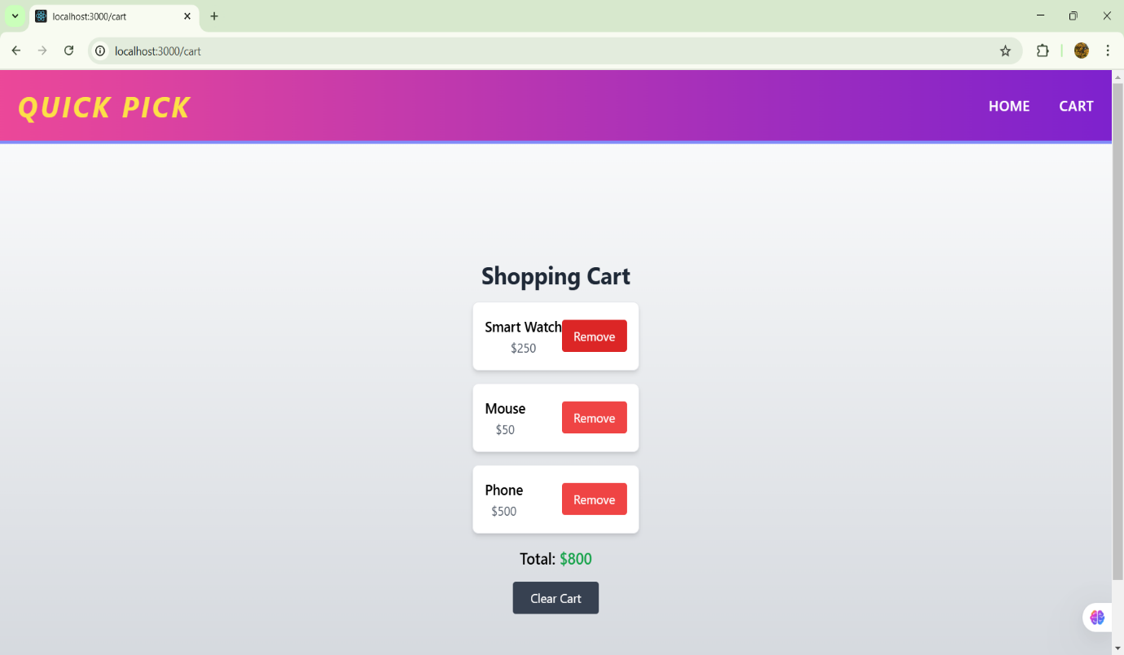

***Removing Items from the Cart***

*Users can remove individual items from the cart by clicking the "Remove" button. This feature allows flexibility in modifying the shopping list before finalizing the order.*

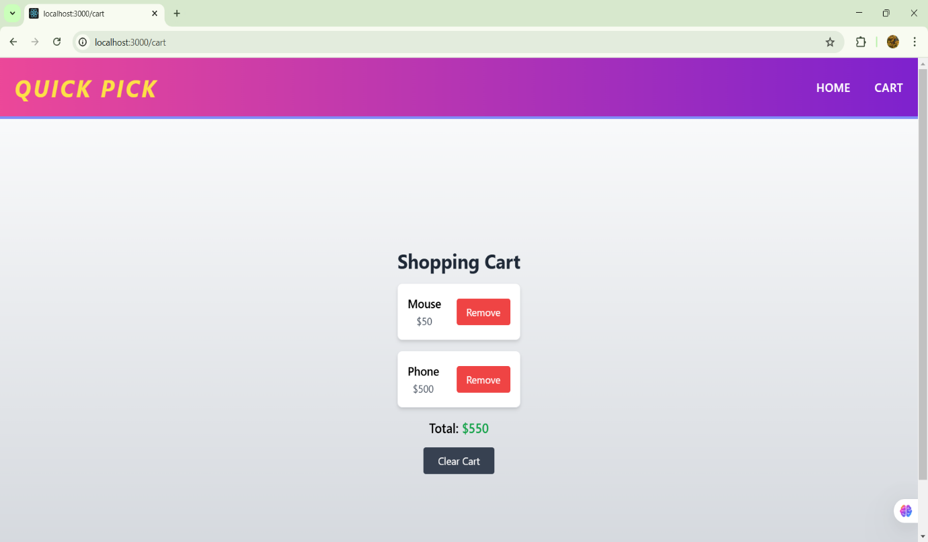

***Clearing the Cart***

*A "Clear Cart" button is available for users who wish to remove all items from the cart in one click. This ensures a hassle-free shopping experience.*

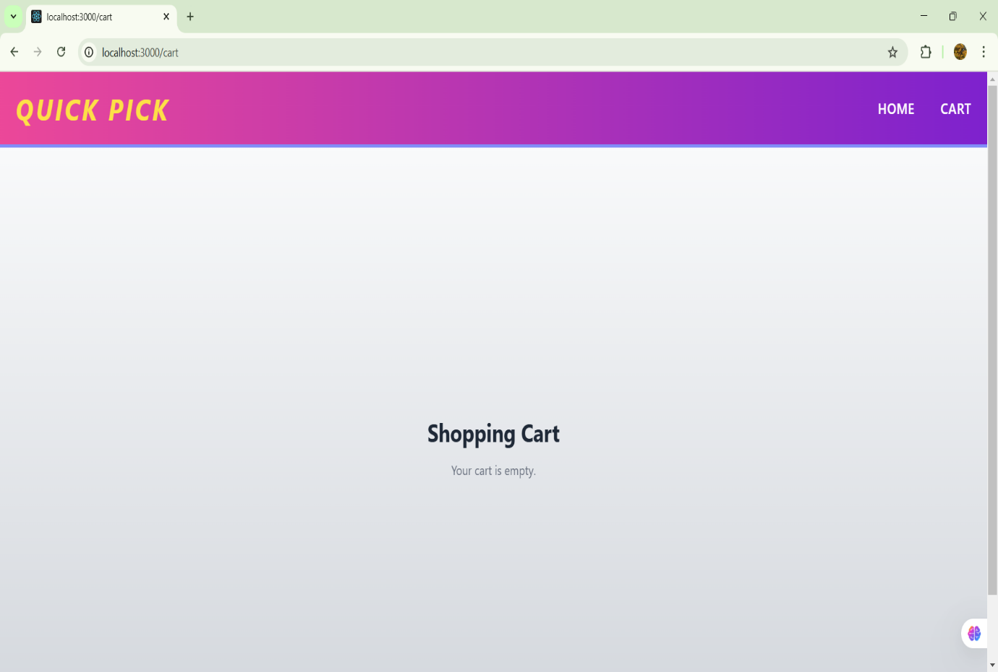

*This e-commerce website is built with React, React Router, Context API, and Tailwind CSS, ensuring a seamless and interactive shopping experience. The UI is designed to be simple, user-friendly, and responsive.*